Odds & Evens

Prerequisite: The child must know how to make quantities up to 10 and must be able to identify numbers to 10.

Material: Numbers and Counters

Printable version found here
Purchase wooden material here
DIY version:
- Cut 10 pieces of cardstock about half of postcard size
- With the cards laying long side up, write the numbers 1 through 10 on them in red with a thick marker (one number per card)
- Include 60 counters (they must be the same item, same color and size - here’s an example)
- Place everything in a box or basket (counters gathered in a box)

Presentation:
- Invite the child to set out the cards across a rug in order, 1 to 10.
- Ask them to say the numbers out loud.
- Invite them to place the counters as per the Numbers and Counters lesson.
  - The counter for 1 goes directly below the number 1.
  - The counters for 2 go side by side under the number 2.
  - The counters for 3 go as follows: counters 1 and 2 are placed side by side, and the third counter is placed below the first two counters, and between them.
  - The counters for 4 are placed as follows: counters 1 and 2 are placed side by side, and counters 3 and 4 are also placed side by side, below counters 1 and 2.

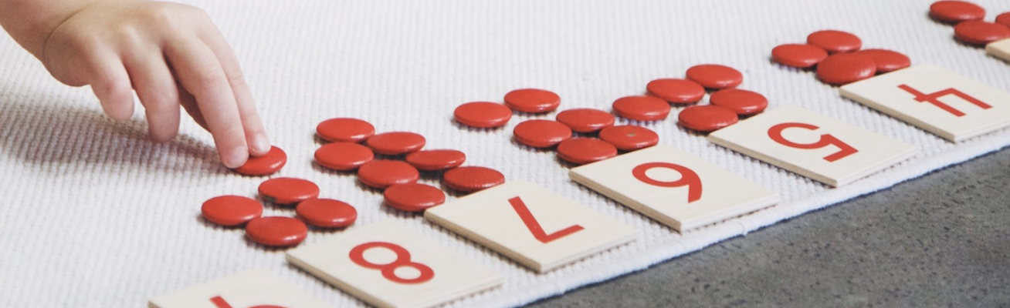

- The child continues following the pattern until they reach 10.
- To illustrate odds and evens, tell your child that you’re going to pretend that your finger is a car. Run your finger up towards the counter for 1 and stop. Point out that it’s in the way and won’t let you touch the card that says 1.
- Move to the next number: 2. Run your finger up towards the two counters, and show how it can slide between the counters to reach the card. Push the card up so that it’s higher than its original placement.
- Move to the next number: 3. Run your finger up towards the counters, and show how the third counter stops you from reaching the card for 3.
- Move to the next number: 4. Run your finger up towards the counters, and show how it can slide between the counters to reach the card. Push the card up so that it’s higher than its original placement.
- If your child is ready, they can continue on their own.
- When they’re done, the even number cards will be higher than the odd numbers.
- Explain to your child that those numbers are called “even numbers.” Ask the child to read the even numbers. Then ask the child to read the odd numbers.
- If necessary, do a three-period lesson: “Show me odd numbers, show me even numbers.” If they do well, ask: “Is 3 an odd number or an even number? Is 6 an odd number or an even number?”
- If your child wants to re-do the activity, bring the cards back down and let them start over.

Extensions:
- You can play games outdoors where you ask your child to bring you an odd number of rocks, or an even number of rocks.
- You can skip-count by twos using the bead bars of two.

